YEAR 6 Unit 5
Wild animals-There was/were
Today Past
There is… There was…
There are…. There were…

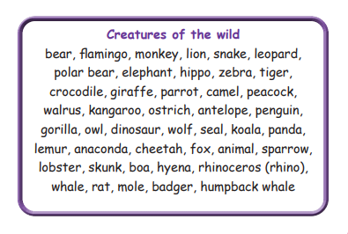
Pupil’s book, page 75

Let’s practice
- What animals were there in Noah’s Arc? Make sentences using: There was…./There were…
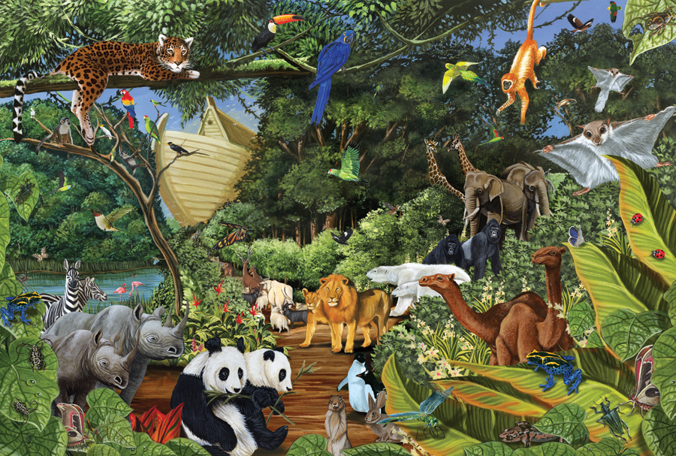
Example: There were two camels. ………………………………………………………………………………………………………………………………………………………………………………………………………………………………………………………………………………………………………………………………………………...................................................................
- Put the words in the right order
- there/lions/were/the/at/zoo
……………………………………………………………………………………………………………………………………………….
- was/rabbit/there/the/in/farm/a
……………………………………………………………………………………………………………………………………………….
- yesterday/were/two/parrots/there/on/tree/the
……………………………………………………………………………………………………………….………………………………
- wasn’t/penguin/at/safari park/there/a/the/last year
……………………………………………………………………………………………………………………………………………....
- were/many/there/birds/in/garden/the/yesterday
……………………………………………………………………………………………………………………………………………….

- Scrambled words. Can you unscramble them?
ymkoen | monkey
nhori
leetanhp
beraz
fefirga
hteceha
ecorldcoi
oisthcr
nofmgali

Name:……………………………………………………………………………………………………………… Class:…………………………….

