NUMBERS 1-20
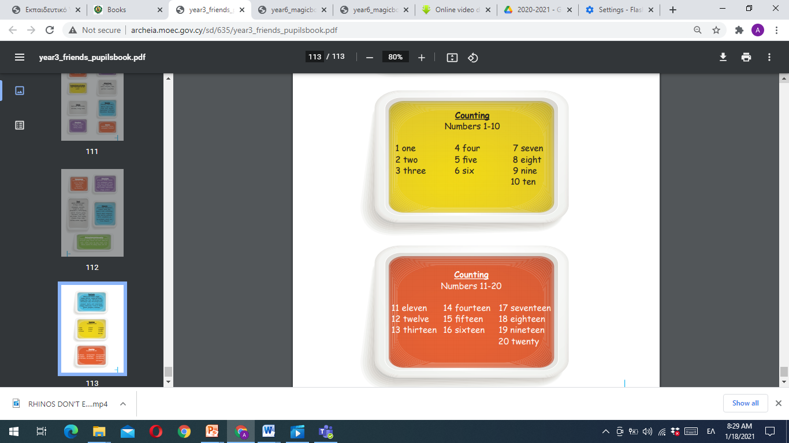

Year 3, Pupil’s book, page 113

Let’s practice
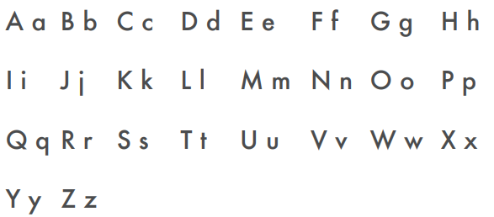
- Write the words in small letters.
FOUR ………………………
SEVEN ………………………
TWENTY ………………………
FIFTEEN ………………………
TEN ………………………
THIRTEEN ………………………
ONE ………………………
NINETEEN ………………………
EIGHT ………………………
TWELVE ………………………

- Unscrambe the words.
3 | etrhe | three
7 | snvee
11 | nveele
18 | nteeigeh
20 | ntywet

